Certificate in C# Advanced Programming

Creating Web Applications in C#

By Randal Root

# Module 07: Data Driven Applications

“At the beginning of this book, you learned that ASP.NET is just one component in Microsoft’s ambitious .NET platform. As you know, .NET also includes modern languages and a toolkit of classes that allows you to do everything from handling errors to analyzing XML documents. In this chapter, you’ll explore another one of the many features in the .NET Framework: the ADO.NET data access model.” (Beginning ASP.NET 4.5 in C#, Chapter 14, MacDonald)

The ADO.NET programming model consists of five core objects

* Connection object

* Command object

* DataReader object

* DataAdapter object

* DataSet object

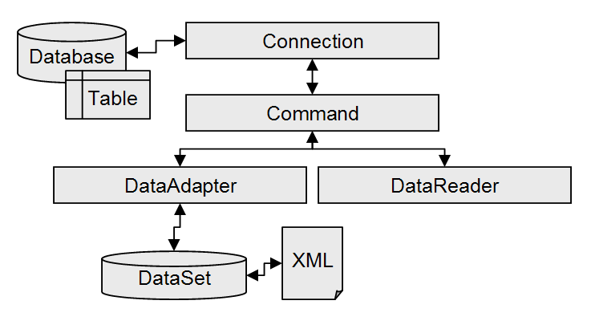

The figure above shows an overview of how the different components work together.

* The Connection object provides the connection to the database.
* The Command object executes a command against a data source. It can execute non-query commands, such as INSERT, UPDATE, or DELETE, or return a DataReader with the results of a SELECT command.
* The DataReader object provides a forward-only, read-only, connected recordset.
* The DataAdapter object populates a disconnected DataSet or DataTable with data and performs updates.
* The DataSet class, while not truly part of ADO.NET, it is most often used with the DataAdapter to hold an updateable copy of the results from a query. In fact, the DataAdapter is really not much use without it. Updates to the results in a DataSet can be sent back to the original data source or saved to a local XML file.

Here is a simple example of how the objects would be used.

**NOTE**: You need to run the SetupDBCode.sql SQL file before you can test the Module 7 demos.



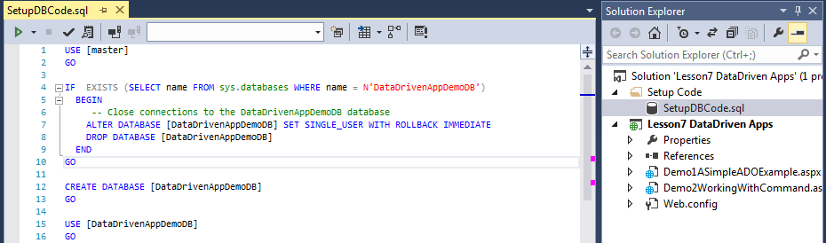

Demo1ASimpleADOExample.aspx

<%@ Page Language="C#" %>

<!DOCTYPE html>

<script runat="server">

protected void Page_Load(object sender, EventArgs e)

{

//1. Make a Connection

System.Data.OleDb.OleDbConnection objOleCon;

objOleCon = new System.Data.OleDb.OleDbConnection();

string strOledbConnection = @"Provider=SQLOLEDB;Data Source=(local);Integrated Security=SSPI;Initial Catalog=DataDrivenAppDemoDB";

objOleCon.ConnectionString = strOledbConnection;

objOleCon.Open();

//2. Issue a Command

System.Data.OleDb.OleDbCommand objCmd;

objCmd = new System.Data.OleDb.OleDbCommand("Select Count(*) From Products", objOleCon);

int intProductCount = (int)objCmd.ExecuteScalar();

//3. Process the Results (if any)

Label1.Text = "<p>Number of items: " + intProductCount.ToString() + "</p>";

//4. Free up resources

objOleCon.Close();

}

</script>

<html xmlns="http://www.w3.org/1999/xhtml">

<head runat="server">

<title></title>

</head>

<body>

<form id="form1" runat="server">

<div>

<asp:Label ID="Label1" runat="server" Text="Label"></asp:Label>

</div>

</form>

</body>

</html>

## LAB 1: A Simple ADO.NET Page

In this lab, you will:

1) Create a web page that indicates how many databases are on a given SQL Server.

**Tip:** Use the table/view called SysDatabases in the Master database.

**This lab should take about 5 to 10 minutes**

## The Connection Class

The Connection class sets up the information necessary to attach to a database. It has a number of properties available to specify this information, such as username and password, as well as, of course, the location of the database. After creating the Connection object and setting its properties correctly, you’ll call the Open() method of the Connection object, which actually creates the connection to the database and opens it.

**C#, SQL Server Connection**

using System.Data.SQLClient;

…

SqlConnection nwindConn =

new SqlConnection("Data Source=localhost; Integrated Security=SSPI; Initial Catalog=northwind");

nwindConn.Open();

**C#, ODBC Connection**

using System.Data.Odbc

…

OdbcConnection nwdCn =

new OdbcConnection("Driver={SQL Server};Server=localhost; Trusted_Connection=yes;Database=northwind");

nwdCn.Open();

Both Trusted_Connection=yes or Integrated Security=SSPI options will log onto the server using Windows Authentication, which means your Windows logon rather than using a username/password combination. This is a more secure way of coding so that you don’t have to embed password information into your code, if your database administrator has created a logon for you that maps to your Windows account.

Windows accounts work well if users are logged into the same domain, such as on an internal site, but less so when they are browsing to your site on the Internet. For those types of connections, you need to use a SQL Login.

@"Provider=SQLOLEDB; Data Source=is-root01.ischool.uw.edu; User ID=CSharp; Password=sql; Initial Catalog=DataDrivenAppDemoDB";

## Making a Connection Visually

If you are using the full version of Visual Studio and not just the Express version, you can use Server Explorer to create a connection. (Not SQL Server Explorer)

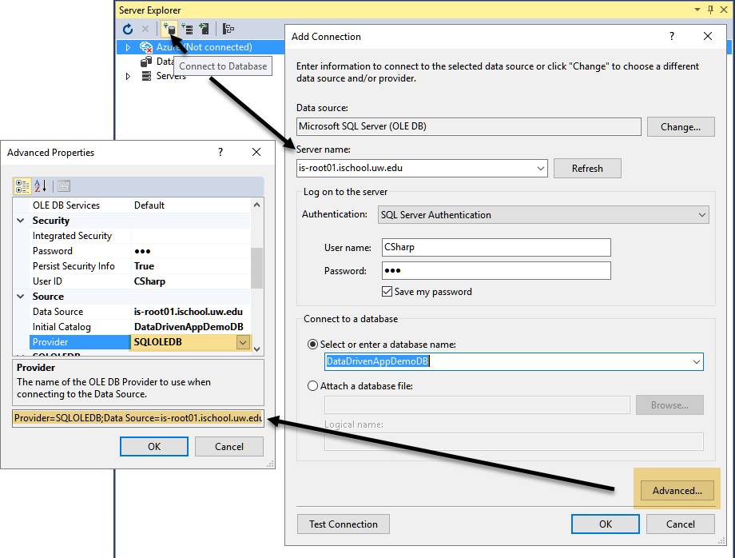

After you have selected the Data Source, you can configure both simple and advance options.

Once a connection has been created in Server Explore you can use it much like you would the SQL Management Studio, including creating tables, views, and stored procedures.

# Connections Strings

If you are going to use the connection in more than one web page, you should move your connection string to the web.config file and referencing it from your web pages. You can do this yourself using the following code in the web.config file:

connectionString="Provider=SQLOLEDB;Data Source=localhost;Integrated Security=SSPI;Initial Catalog=northwind"/>

connectionString= "Provider=SQLOLEDB;Data Source=is-root01.ischool.uw.edu;User ID=CSharp;Password=sql;Initial Catalog=Northwind"/>

Goes into...

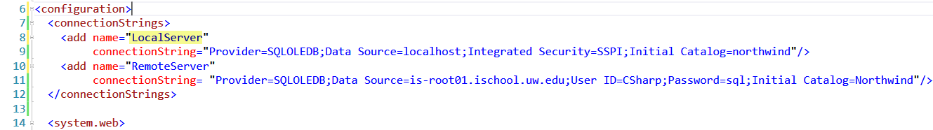

Followed by this code in your ASP.NET pages:

//1. Make a Connection

System.Data.OleDb.OleDbConnection objOleCon;

objOleCon = new System.Data.OleDb.OleDbConnection();

string strOledbConnection = ConfigurationManager.ConnectionStrings["LocalServer"].ConnectionString;

objOleCon.ConnectionString = strOledbConnection;

objOleCon.Open();

## LAB 2: Connection Strings

In this lab, you will:

1) Make a copy of your Lab1 web page, then modify the new web page so that it uses a connection string from the Web Config file.

**This lab should take about 5 minutes**

## Working with Commands

The ADO Command object let you send code to the database engine for processing. It also identifies which type of result you expect to get back (nothing, a single value, or a table of values).

### Demo2WorkingWithCommand.aspx

<%@ Page Language="C#" %>

<!DOCTYPE html>

<script runat="server">

protected void Button1_Click(object sender, EventArgs e)

{

//1. Make a Connection

System.Data.OleDb.OleDbConnection objOleCon;

objOleCon = new System.Data.OleDb.OleDbConnection();

objOleCon.ConnectionString = ConfigurationManager.ConnectionStrings["LocalServer"].ConnectionString;

objOleCon.Open();

//2. Issue a Command

System.Data.OleDb.OleDbCommand objCmd;

objCmd = new System.Data.OleDb.OleDbCommand();

objCmd.Connection = objOleCon;

objCmd.CommandType = System.Data.CommandType.Text;

//Not normally typed out since Text is the default anyway

//3. Process the Results

//3a. Commands without Results

//When you don't need results back, like these two examples, use ExecuteNonQuery()

objCmd.CommandText = @"Create Table Demo1 (ID int Primary Key, Name nVarchar(50))";

Label1.Text = "<p>No Results</p>";

try

{

int RowsAffected = objCmd.ExecuteNonQuery();

// Ex. Inserts, Updates, Deletes SQL commands

Label1.Text += "<p>Table Created</p>";

}

catch (Exception ex)

{

Label1.Text += ex.Message.ToString() + "<hr/>";

}

objCmd.CommandText = @"Insert Into Demo1 (ID, Name) Values(1, 'Test Data')";

try

{

int RowsAffected = objCmd.ExecuteNonQuery();

// Ex. Inserts, Updates, Deletes SQL commands

Label1.Text += "<p>Row Added</p>";

}

catch (Exception ex)

{

Label1.Text += ex.Message.ToString() + "<hr/>";

}

//3b. Commands with one Result

objCmd.CommandText = "Select Count(*) From Demo1";

try

{

int intResult = (int)objCmd.ExecuteScalar();

Label2.Text = "<p>Scalar Result</p>";

Label2.Text += "<p>Number of Row in Table: " + intResult.ToString() + "</p>";

}

catch (Exception ex)

{

Label2.Text += ex.ToString();

}

//3c. Commands multiple Results

objCmd.CommandText = "Select ID, Name From Demo1";

System.Data.OleDb.OleDbDataReader objDR;

try

{

objDR = objCmd.ExecuteReader();

Label3.Text = "<p>Multiple Results</p>";

while (objDR.Read() == true)

{

Label3.Text += "<p>"

+ objDR["ID"].ToString() + ", " + objDR["Name"].ToString()

+ @"</p>";

}

objDR.Close();

}

catch (Exception ex)

{

Label3.Text = ex.ToString();

}

//4. Free up Resources

objOleCon.Close();

}

</script>

<html xmlns="http://www.w3.org/1999/xhtml">

<head runat="server">

<title></title>

</head>

<body>

<form id="form1" runat="server">

<div>

<asp:Label ID="Label1" runat="server" Text="Label1"></asp:Label>

<br />

<asp:Label ID="Label2" runat="server" Text="Label2"></asp:Label>

<br />

<asp:Label ID="Label3" runat="server" Text="Label3"></asp:Label>

<br />

</div>

<asp:Button ID="Button1" runat="server" OnClick="Button1_Click" Text="Button" />

</form>

</body>

</html>

## LAB 3: Displaying a list of Products in an ADO.NET Page

In this lab, you will:

1) Create a web page that displays a list of product and category names in an html table.

**Tip:** Use the view called vProductsByCategories in the DataDrivenAppDemoDB database.

SELECT CategoryName, ProductName FROM vProductsByCategories

**This lab should take about 10 to 15 minutes**

# Using SQL Abstraction Layers

In the last lab, we use a SQL view that "projects" data from two tables. Querying views instead of tables is a best practice. If you want to work with transactional data processing, you use SQL stored procedures instead.

A very simple insert stored procedure might look like this one:

Create Procedure pInsCategories

(@CategoryName [nvarchar](50), @NewCategoryID int Output)

As

Begin

Declare @StatusCode int = 0;

Begin Try

Insert Into [Categories]([CategoryName]) Values(@CategoryName);

Set @NewCategoryID = @@IDENTITY;

Set @StatusCode = +100;

End Try

Begin Catch

Set @StatusCode = -100;

End Catch

Return @StatusCode;

End

Go

You would execute this "Sproc" using the following code:

Declare @RC int, @NewID int;

Exec @RC = pInsCategories @CategoryName = 'Cat1', @NewCategoryID = @NewID Output;

Select @RC, @NewID;

The code in your web page now changes to call the stored procedure and pass in the parameter values.

* Configuring Parameters and Parameter Data Types
  + <https://msdn.microsoft.com/en-us/library/yy6y35y8(v=vs.110).aspx>

### Demo3WorkingWithSprocs.aspx

<%@ Page Language="C#" %>

<script runat="server">

protected void Page_Load(object sender, EventArgs e)

{

//1. Make a Connection

System.Data.OleDb.OleDbConnection objOleCon;

objOleCon = new System.Data.OleDb.OleDbConnection();

objOleCon.ConnectionString = ConfigurationManager.ConnectionStrings["LocalServer"].ConnectionString;

objOleCon.Open();

//2. Issue a Command

System.Data.OleDb.OleDbCommand objCmd;

objCmd = new System.Data.OleDb.OleDbCommand("pInsCategories", objOleCon);

objCmd.CommandType = System.Data.CommandType.StoredProcedure;

//2.1 Add Parameters

// Declare @RC int, @NewID int;

// Exec @RC = pInsCategories @CategoryName = 'Cat1', @NewCategoryID = @NewID Output;

System.Data.OleDb.OleDbParameter objRC;

objRC = new System.Data.OleDb.OleDbParameter("@RC", System.Data.OleDb.OleDbType.Integer);

objRC.Direction = System.Data.ParameterDirection.ReturnValue;

objCmd.Parameters.Add(objRC);

System.Data.OleDb.OleDbParameter objCatName;

objCatName = new System.Data.OleDb.OleDbParameter("@CategoryName", System.Data.OleDb.OleDbType.VarWChar, 50);

objCatName.Direction = System.Data.ParameterDirection.Input;

objCatName.Value = "Cat from Web";

objCmd.Parameters.Add(objCatName);

System.Data.OleDb.OleDbParameter objNewID;

objNewID = new System.Data.OleDb.OleDbParameter("@NewCategoryID", System.Data.OleDb.OleDbType.Integer);

objNewID.Direction = System.Data.ParameterDirection.Output;

objNewID.DbType = System.Data.DbType.Int32;

objCmd.Parameters.Add(objNewID);

//2.2 Execute the code

objCmd.ExecuteNonQuery();

//3. Process the Results (if any)

// Select @RC, @NewID;

Label1.Text += "<p>Return Code: " + objCmd.Parameters["@RC"].Value.ToString() + "</p>";

Label1.Text += "<p>New Category ID: " + objCmd.Parameters["@NewCategoryID"].Value.ToString() + "</p>";

//4. Free up resources

objOleCon.Close();

}

</script>

<!DOCTYPE html>

<html xmlns="http://www.w3.org/1999/xhtml">

<head runat="server">

<title></title>

</head>

<body>

<form id="form1" runat="server">

<div>

<asp:Label ID="Label1" runat="server" Text="Label"></asp:Label>

</div>

</form>

</body>

</html>

# Creating a Data Driven Web Site using the Entity Framework

The web applications may also consist of an Entity Framework Data Model over ADO.NET connecting to a SQL Server Database. The Entity Framework still uses the core ADO.NET objects, but provides an abstraction layer over the top of it.

Depending on the version of Visual Studio the Entity Framework (EF) may already be installed, but if not you can install the Entity Framework using the NuGet Console. You can find more information about how this works on the Nuget website here: <https://www.nuget.org/packages/EntityFramework/5.0.0>

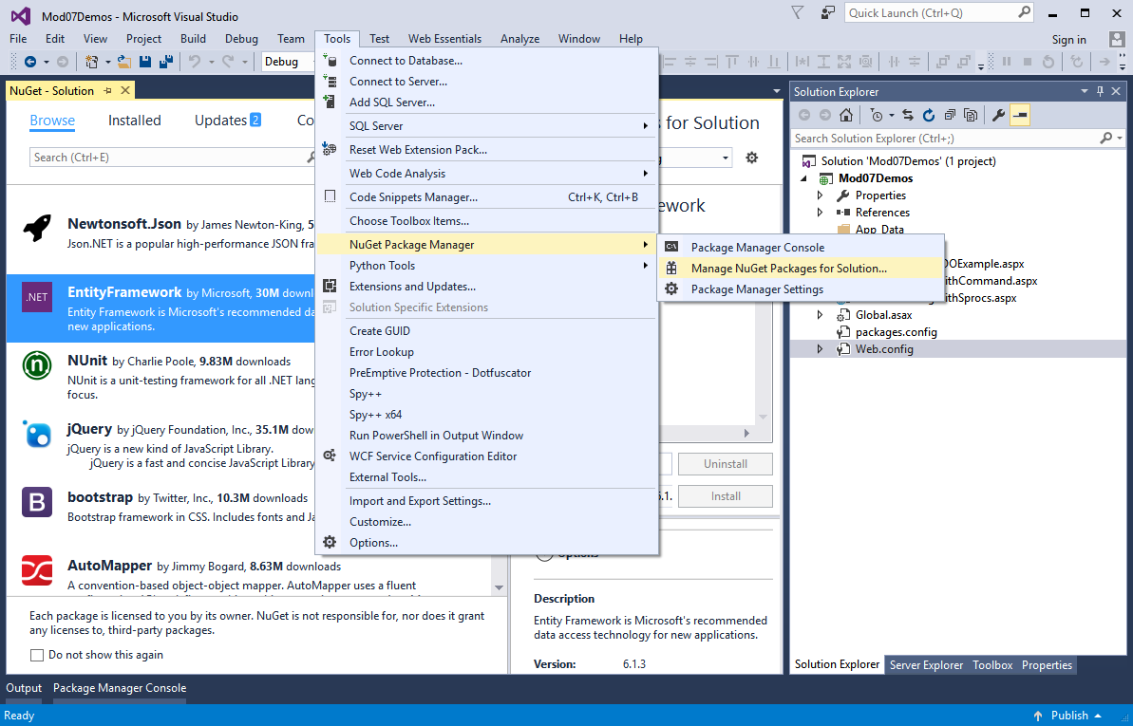

You can also add and execute the following command to add the EF to your project.

PM> Install-Package EntityFramework -Version 6.0.0

NOTE: Review the script file again and make sure you understand what is created before you move on.

Follow these instructions to create a new EF data model:

1) Add a new Data Model to the Models folder of the project called Model1. Right-Click your Project icon in Solution Explorer, then select Add->New Item from the context menu. Select the ADO .NET Entity Data Model option.

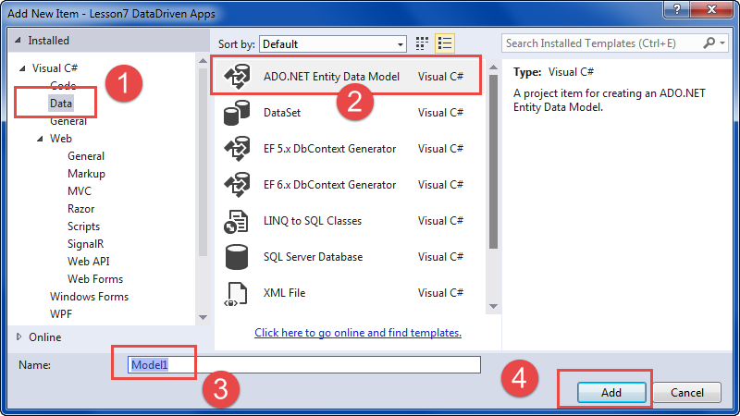

**Note**: In VS 2013 you can Right-Click your Project icon in Solution Explorer and then select Add->ADO .NET Entity Data Model from the context menu.

2) When the Entity Data Model Wizard appears, select the “EF Designer from database” option.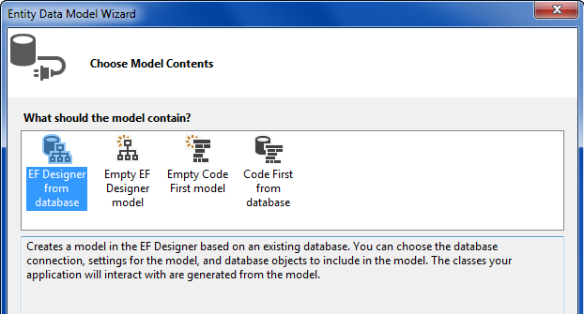

3) Connect to your server and the new DataDrivenAppDemoDB.

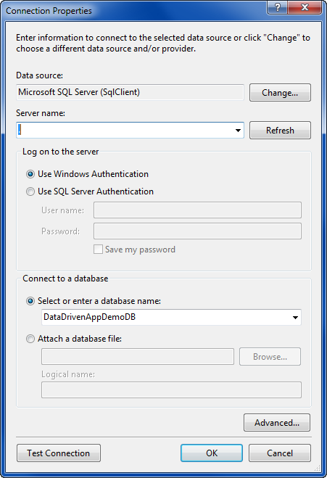

4) IF it asks you, choose to use EF 6 for this demo.

5) Choose the Categories and Products tables and their associated stored procedures. Do not include the DemoLog table and its pInsDemoLog stored procedure. Leave the Views unchecked for now as well.

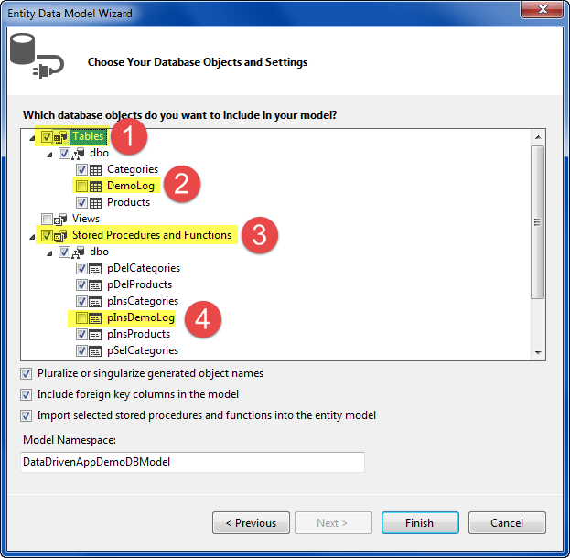

**Tip**: Note the Model namespace for later.

6) Respond to the Security warning by clicking the OK button.

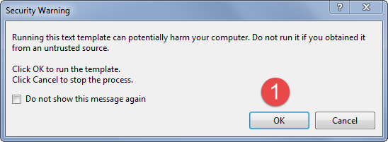

7) Review the new EF Diagram.

1. The Model diagram
2. Mapping Details
3. The Model Browser
4. The Entity Types
5. The imported Stored Procedures and Functions

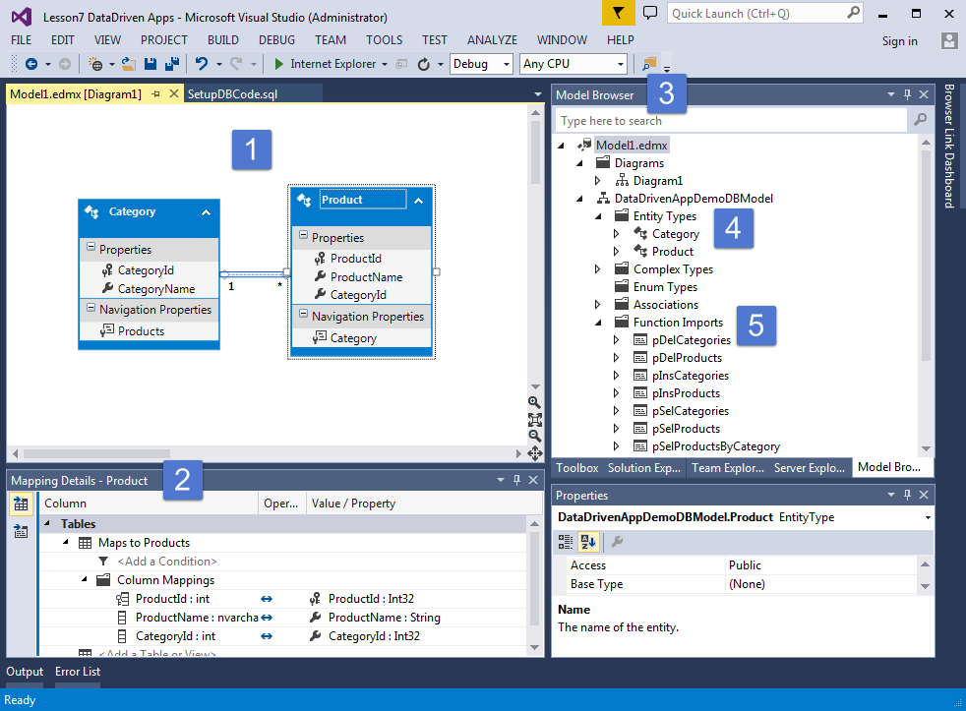

## Creating web pages with the Entity Framework

With the EF model we can now let it handle the tasks of connecting, issuing commands, and returning results.

#### Demo4WorkingWithEF.aspx

<%@ Page Language="C#" %>

<!DOCTYPE html>

<script runat="server">

Mod07Demos.DataDrivenAppDemoDBEntities objEF;

protected void Page_Load(object sender, EventArgs e)

{

objEF = new Mod07Demos.DataDrivenAppDemoDBEntities();

}

protected void Button1_Click(object sender, EventArgs e)

{ //Select From a Table

Label1.Text = "";

foreach (Mod07Demos.Product row in objEF.Products)

{

Label1.Text += "<p>" + row.ProductId.ToString()

+ ", " + row.ProductName.ToString()

+ ", " + row.CategoryId.ToString()

+ "</p>";

}

}

protected void Button2_Click(object sender, EventArgs e)

{

//Insert using a stored procedure

Label2.Text = "";

try

{

objEF.pInsProducts(TextBoxProductName.Text, int.Parse(TextBoxCategoryId.Text));

Label2.Text = "Inserted";

}

catch (Exception ex)

{ Label2.Text = ex.Message.ToString(); }

}

</script>

<html xmlns="http://www.w3.org/1999/xhtml">

<head runat="server">

<title>Demo4</title>

</head>

<body>

<form id="form1" runat="server">

<div>

<asp:Button ID="Button1" runat="server" OnClick="Button1_Click" Text="Select Button" />

<br />

<asp:Label ID="Label1" runat="server" Text="Label1"></asp:Label>

<br />

<asp:Button ID="Button2" runat="server" OnClick="Button2_Click" Text="Insert Button" />

<br />

<asp:Label ID="LabelProductName" runat="server" Text="ProductName: "></asp:Label>

<asp:TextBox ID="TextBoxProductName" runat="server"></asp:TextBox>

<br />

<asp:Label ID="LabelCategoryId" runat="server" Text="CategoryId: "></asp:Label>

<asp:TextBox ID="TextBoxCategoryId" runat="server"></asp:TextBox>

<br />

<asp:Label ID="Label2" runat="server" Text="Label2"></asp:Label>

<br />

</div>

</form>

</body>

</html>

## LAB 4: Displaying a list of Products in an ADO.NET Page

In this lab you will:

1) Create a web page that displays a list of product and category names in an html table, this time using the Entity Framework.

**Tip:** Use the view called vProductsByCategories in the DataDrivenAppDemoDB database, but you will have to add it to the EF model first.

SELECT CategoryName, ProductName FROM vProductsByCategories

**This lab should take about 10 to 15 minutes**

# Reading Assignment

Please read Chapter 14 of your text book, Beginning ASP.NET 4.5 in C#.

# Homework

Work on the class project.